
CANKAYA UNIVERSITY
OFFICE OF BASIC & ELECTIVE COURSES
-ENGLISH UNIT-
2011-2012 ACADEMIC YEAR
SPRING TERM
ENG 111 ENGLISH FOR ACADEMIC PURPOSES I
TOP NOTCH-UNIT 3

A. Complete each sentence with a word or phrase from the box. You will not use all the words.

*flush *clogged *a lemon *making a funny sound
*obsolete *stuck *open *turn on

- The iron won’t __________. I think it’s broken.
- The toilet won’t __________. Please call the front desk clerk!
- The door won’t __________. Where is your key?
- The fridge is __________. It’s very loud!
- I need to print this page, but my new printer won’t turn on. It’s __________.

B. Look at the pictures. Complete each sentence with the correct machine or piece of electronic equipment from the box. There are three extra words.
* DVD player *smart phone * flash drive *mobile phone

*television *printer *laptop *fax machine

- This __________ isn’t working! It’s driving me crazy! 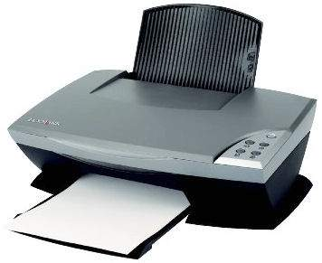
2.Nathan is looking for a new __________.He likes to work when he commutes to work. 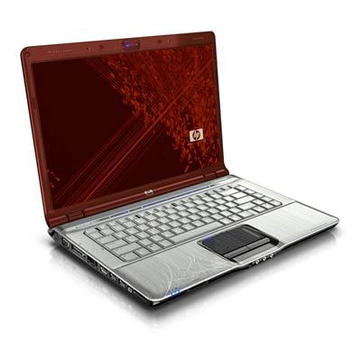

3. Excuse me! Please turn off your __________ in the theater. 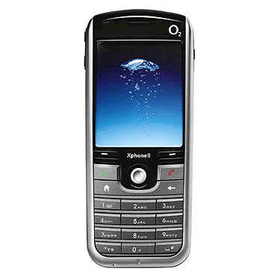

- That __________ is huge! Look at the size of that screen! It’s like being in a movie theater.

- That’s awesome! He’s watching up-to-date TV shows on his new __________. 