
CANKAYA UNIVERSITY
OFFICE OF BASIC & ELECTIVE COURSES
-ENGLISH UNIT-
2011-2012 ACADEMIC YEAR
SPRING TERM
ENG 111 ENGLISH FOR ACADEMIC PURPOSES I
TOP NOTCH-UNIT 2

A) Write the names of the events:
1. 2.
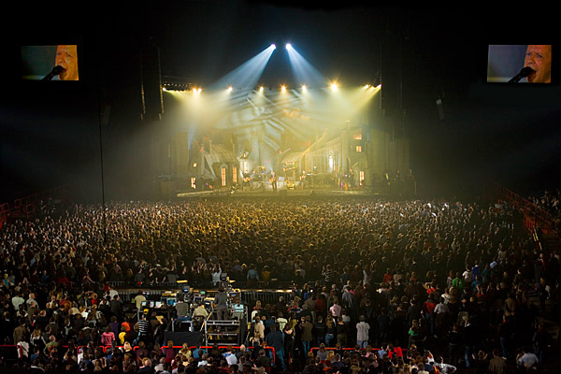
_______________ _____________

3. 4.
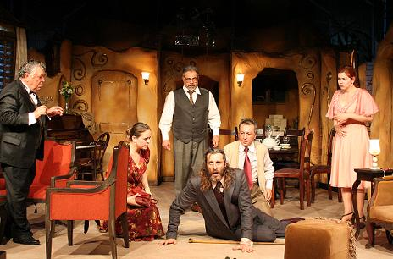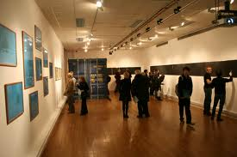
_________________ _________________

5.
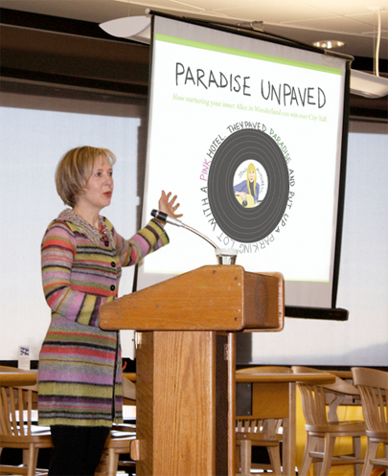
__________________

B) Fill in the blanks with the appropriate words in the box.

genre | hang out | stressed
convenient | expensive | travel

- We want to________ across Eastern Europe by train in our summer vacation this year.
- He has played more than one ________ of music throughout his career, from jazz to disco to rock and even a bit of country and western.
- Suzan is not a very good student. Instead of attending her classes, she prefers to ________ at the universty cafe with her friends.
- I always eat a lot when I feel nervous and ________.
- Clair has ________ tastes. She likes things that cost a lot of money.
- I find it ________ to be able to do my banking by phone, because I often don’t have enough time to go to the bank.

C) Read the text and fill in the blanks with the appropriate words in the box.

relaxed live commute meet available graphic designer

I work in a big company as a/an 1. ________. I draw pieces of pictures for books, magazines, and advertising. My house is far from the company that I work at, so I 2. ________ to work in the mornings and in the evenings. I love my job, but it’s sometimes very demanding. I generally have to work until 8 p.m. and finish the projects in a very short time. If I feel stressed out, I usually spend some time with my friends. I like hanging out with them, because I feel 3. ________ when I am around the people I love. We all like listening to 4. ________ music, so we go to a concert at least once in a month. If we don’t have the chance to go to a concert, we just 5. ________ at the Bisero Café on Lane Street which is close to our neighbourhood. There is also musical performance 6. ________ at this cafe on Saturdays.

